Android Activity Lifecycle methods

Activity: is window / screen of android App on which we can place the widgets. By using life cycle methods we can control the

7 lifecycle methods of android activity.

|  |  |
| --- | --- |
| **Method** | **Description** |
| **onCreate** | called when activity is first created, called only once. |
| **onStart** | called when activity is becoming visible to the user. |
| **onResume** | called when activity will start interacting with the user. |
| **onPause** | called when activity is not visible to the user. |
| **onStop** | called when activity is no longer visible to the user. |
| **onRestart** | called after your activity is stopped, prior to start. |
| **onDestroy** | called before the activity is destroyed. |

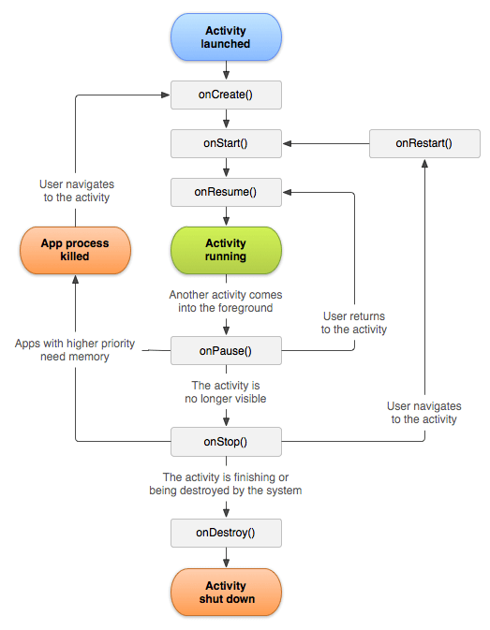

**package** example.javatpoint.com.activitylifecycle;

**import** android.app.*;

**import** android.os.*;

**import android.util.Log;**

**public** **class** MainActivity **extends** Activity {

    @Override

**protected** **void** onCreate(Bundle s) {

**super**.onCreate(s);

        setContentView(R.layout.activity_main);

 // id of layout to fill with all UI

        Log.d("lifecycle","onCreate invoked");

// 1.Where the log message coming from , name of current activity, log info

    }

    @Override

**protected** **void** onStart() {

**super**.onStart();

        Log.d("lifecycle","onStart invoked");

    }

    @Override

**protected** **void** onResume() {

**super**.onResume();

        Log.d("lifecycle","onResume invoked");

    }

    @Override

**protected** **void** onPause() {

**super**.onPause();

        Log.d("lifecycle","onPause invoked");

    }

    @Override

**protected** **void** onStop() {

**super**.onStop();

        Log.d("lifecycle","onStop invoked");

    }

    @Override

**protected** **void** onRestart() {

**super**.onRestart();

        Log.d("lifecycle","onRestart invoked");

    }

**protected** **void** onDestroy() {

**super**.onDestroy();

        Log.d("lifecycle","onDestroy invoked");

    }

}

// d() function is used to Write debug Messages on log

Log.d(name,"str")

//How to open logcat:

Click **View > Tool Windows > Logcat** (or click **Logcat**  in the tool window bar).

